Jenkins integration with Kubernets
Create Jenkins as docker container
Use the same machine to run as Jenkins slave
Docker pipeline plugin
Install Kubernetes Contineous Plugin
Configure kubernetes plugin using kube config file
Prerequisite
Your application to be deployed in kubernetes
Docker file
Kubernetes Cluster
Kubernetes Deployment and service yaml
-----------------------------------------slave node --------------------------------------------------

On slave node
docker run -u 0 --privileged --name jenkins -it -d -p 8080:8080 -p 50000:50000 -v /var/run/docker.sock:/var/run/docker.sock -v $(which docker):/usr/bin/docker -v /home/jenkins_home:/var/jenkins_home jenkins/jenkins:lts
# docker ps
Check the container id
# docker –f container id
Check the logs
Find the field default admin password for jenkins dashboard copy that password
Open the dashboard in browser on localhost ip with port 8080
Example: 192.168.0.18:8080
After dashboard opens
Open the plugins check option available plugins
Select “Docker Pipeline” to install
Follow same process for Kubernetes Contineous Deploy
It shows 2.3 so use download file .hpi to upload for this plugin

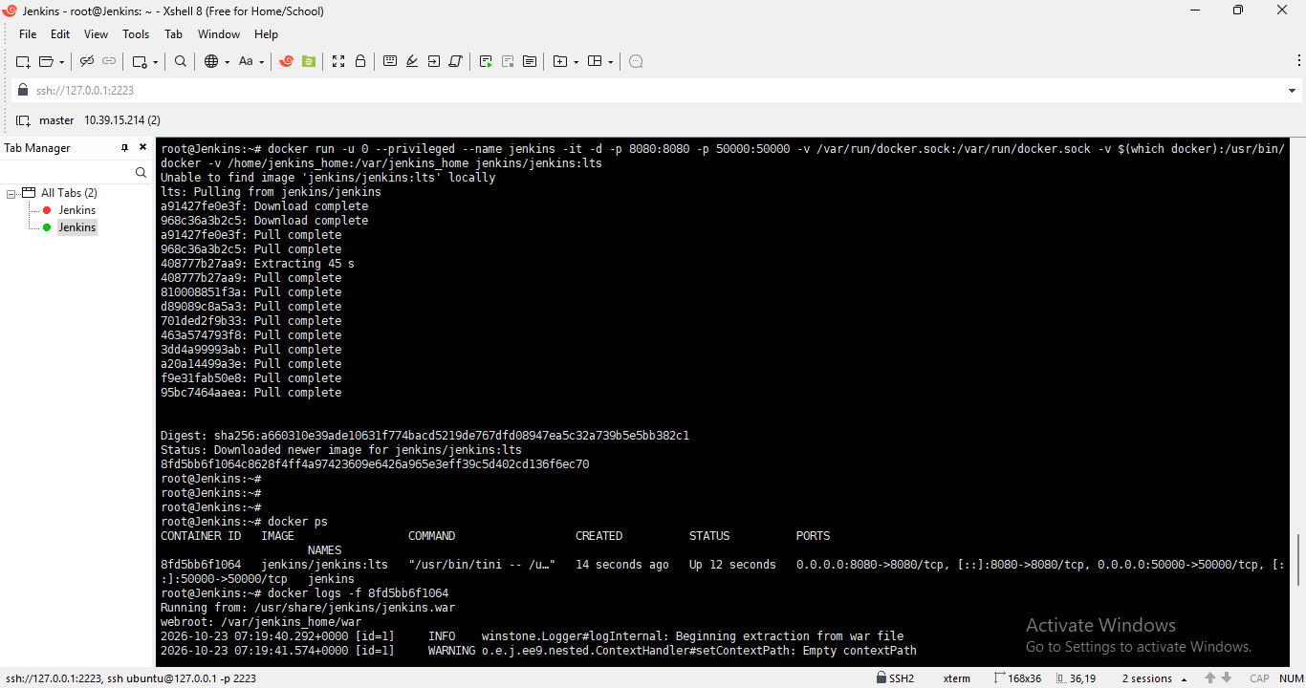

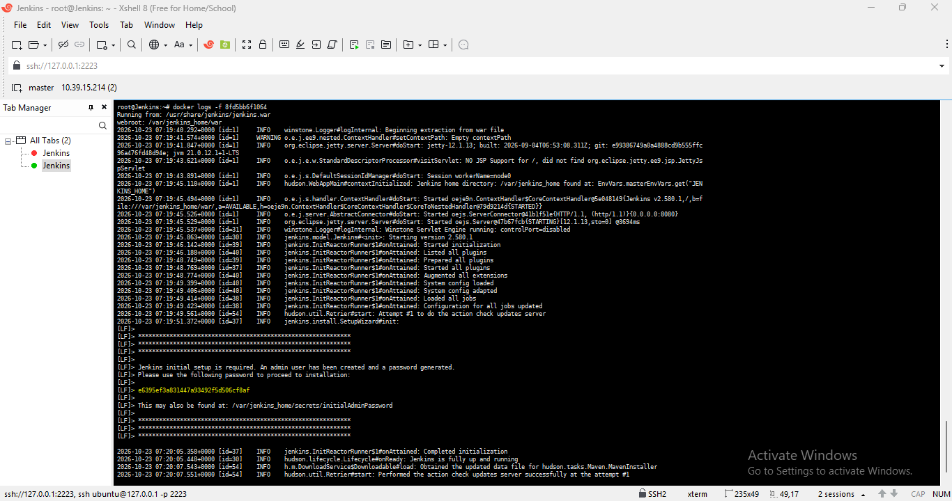
Forward the port in Virtual box to access Jenkins dashboard from local machine browser
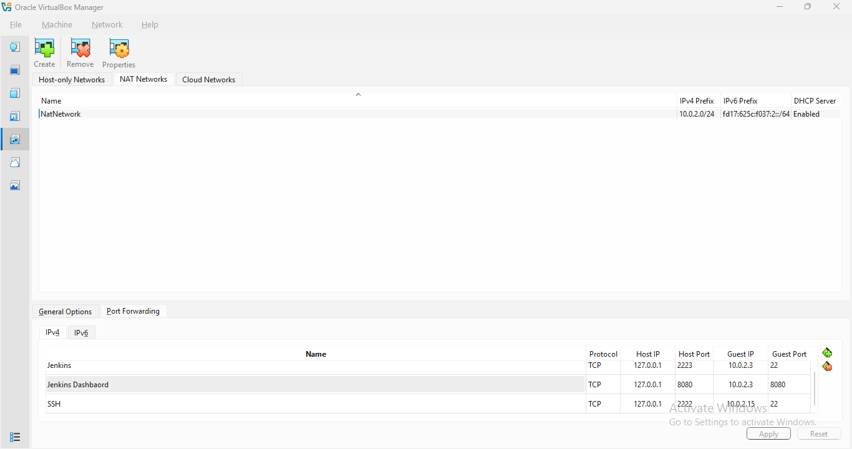
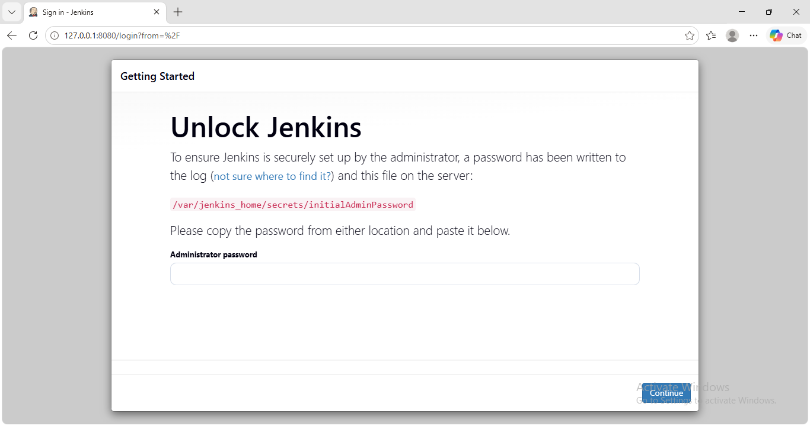

Copy and paste the password from docker logs of Jenkins container
